**User Manual**

**for**

**SupplierManagement**



Created by WeDoIT

This User Guid explains how to use the SupplierManagement-Application developed by WeDoIT for NoKloo’boutIT plc.

Every use-case has a picture of the most important part of the application for the specific step.

**Start SupplierManagement**

To use the SupplierManagement-Application open a Browser of your choice (e.g. Microsoft Edge) and navigate to:

[**http://10.28.2.169**](http://10.28.2.169)

You will be navigated to the Login-Page of the Application.

**Normal User**

**Login:**

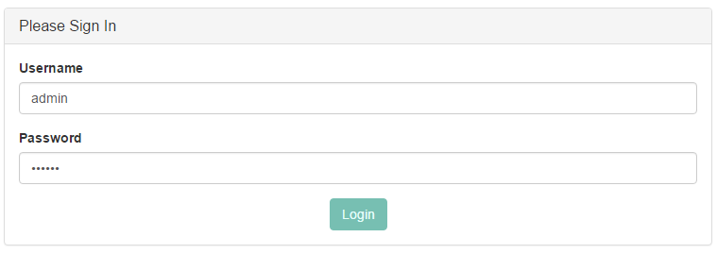

To be able to use our Application you must be logged in. If you have no user account please contact your admin of this Application. To login follow these steps:

1. Fill in your Username
2. Fill in your Password
3. Click login

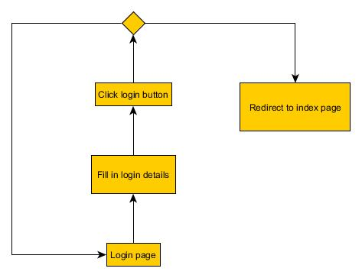

**Logout:**

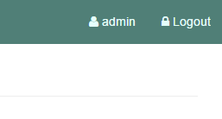

To secure that no unauthorised person is able to use the SupplierManagement please logout after using the Application. You can always logout independent were you are in the Application. To logout follow these steps:

1. Click the logout-button in the upper right corner

**Overview of all Suppliers:**

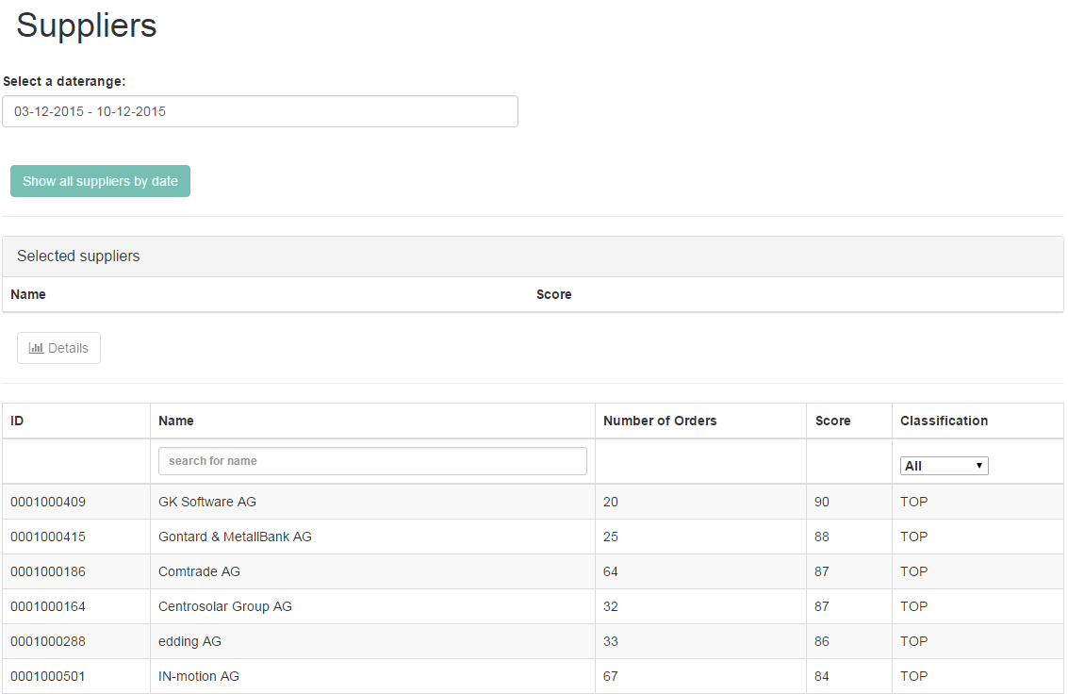

To see an overview of all suppliers with their score and their classification navigate to the Suppliers-Page. You can always navigate to this page if you are logged in. To show the overview of all suppliers follow these steps:

1. Press the Suppliers-Button in the navigation bar on the left

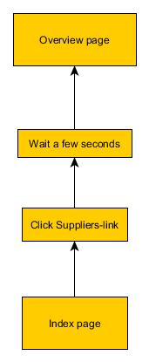

**Filter Overview of all Suppliers by Date:**

In order to filter the overview of the suppliers by date follow these steps:

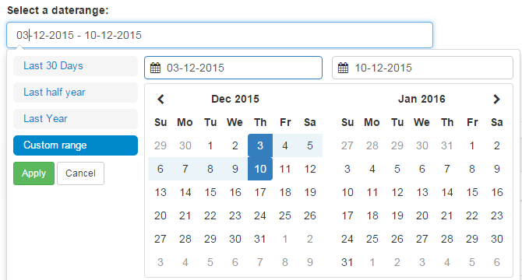

1. Follow the instructions for **Overview of all Suppliers**
2. Pick the date-range you want to filter for
3. Press the “Show all suppliers by date”-Button

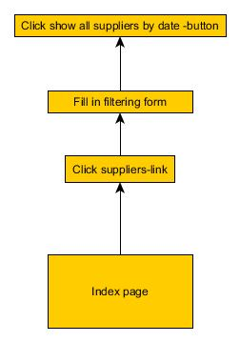

**Filter Overview of all Suppliers by Name and/or Classification:**



In order to filter the overview of the suppliers by name and or by classification follow these steps:

1. Follow the instructions for **Overview of all Suppliers**
2. Type in the name you are searching for and/or choose the classification
3. The list is now filtered

**Compare Suppliers:**

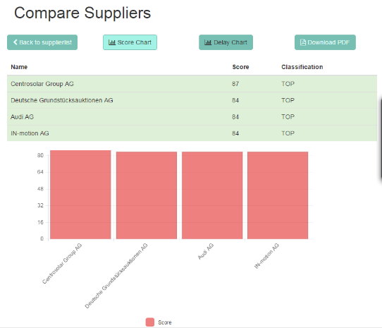

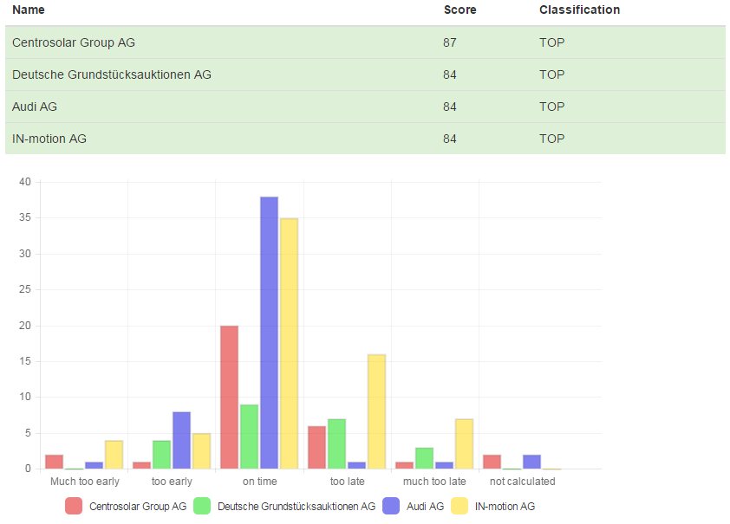

To compare suppliers you first have to follow the instructions for **Overview of all Suppliers**. To select the suppliers which should be compared simply press the suppliers from the overview table. It is possible to select up to four suppliers. No supplier can be selected twice. If only one supplier is selected, you will see a detailed view of that one supplier. Here is a step by step instruction:

1. Follow instructions of **Overview of all Suppliers**
2. Select one or up to four suppliers in the overview-table on the button
3. Press the Compare-Button (Detail-Button if only one supplier is selected)
4. Choice the graphs you want to see by clicking the buttons for the graphs

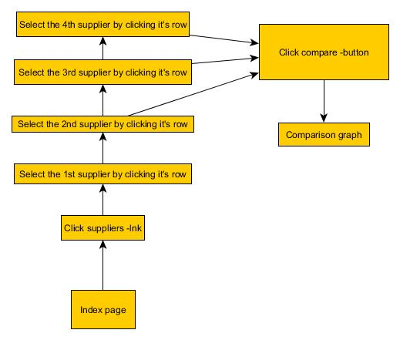

You are able to disable or enable disabled supplier again by clicking them in the table were the suppliers are listed. It is not possible to disable all suppliers

**Export Graphs to PDF:**

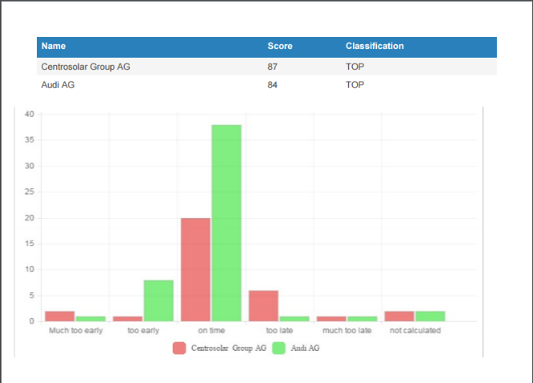

The Graphs shown in **Compare Suppliers** can be exported as PDF. The actual shown Graphs are the one who will be exported. One or more Graphs must be enabled in order to be able to export the PDF. To export the PDF follow these steps:

1. Follow instructions for **Compare Suppliers**
2. Press the “Download PDF” Button
3. The PDF will be downloaded

**Admin User**

If you login as admin user you will have more options than the normal user. As admin it is possible to change the limits for the classification as well as for the scoring. Furthermore the admin is able to create, edit and delete users.

**Settings**

**Change Limits for Classification:**

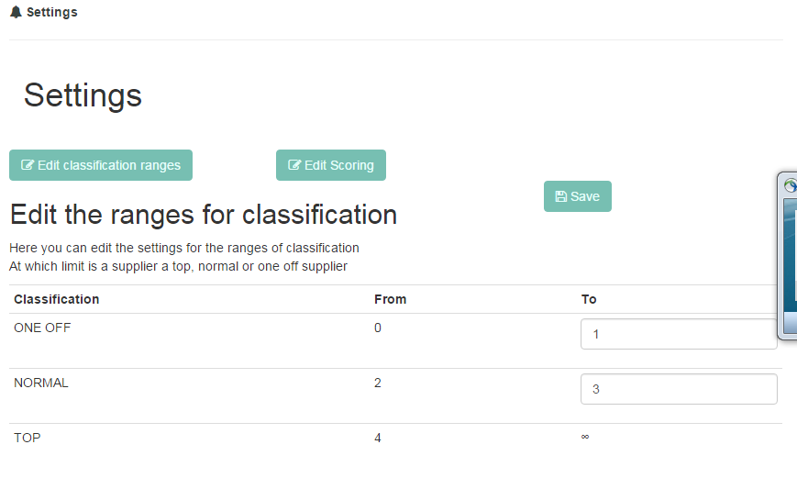

These limits will be used, to categorise the suppliers in the categories “TOP”, “NORMAL” and “ONE_OFF”. To change the limits for the classification follow these instructions.

1. Navigate to the Settings-Page by click on “Settings” in the left navigation bar
2. Choose “Edit classification ranges”
3. Change your limits
4. Press the Save-button in order to save the new limits

**Change Limits for Scoring:**

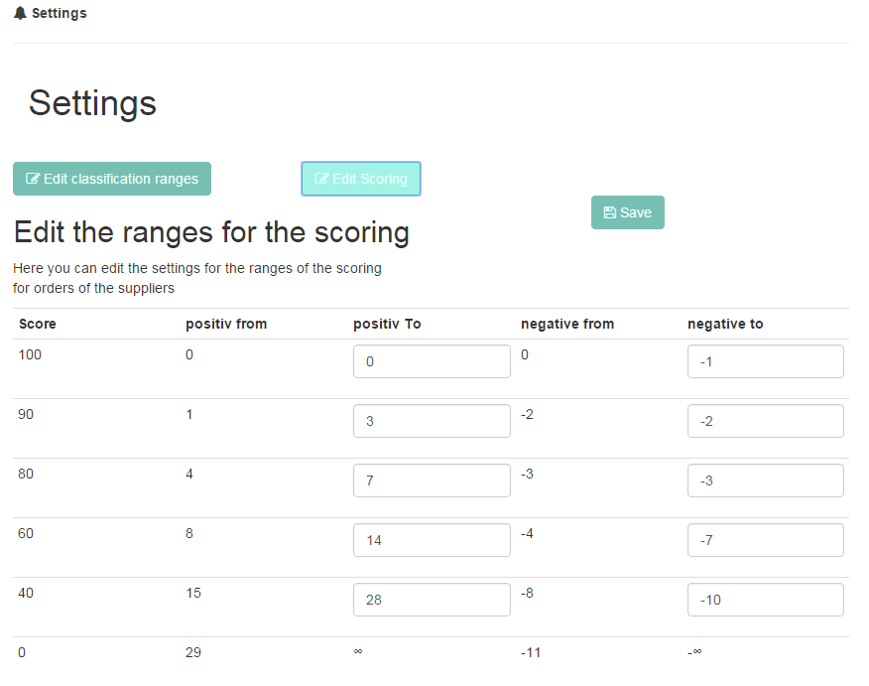

These limits will be used, to calculate the score of every order and therefore to calculate the score of each supplier. To change the limits for the scoring follow these instructions.

1. Navigate to the Settings-Page by click on “Settings” in the left navigation bar
2. Choose “Edit Scoring”
3. Change your limits
4. Press the Save-button in order to save the new limits

**User Management**

**Create new User:**

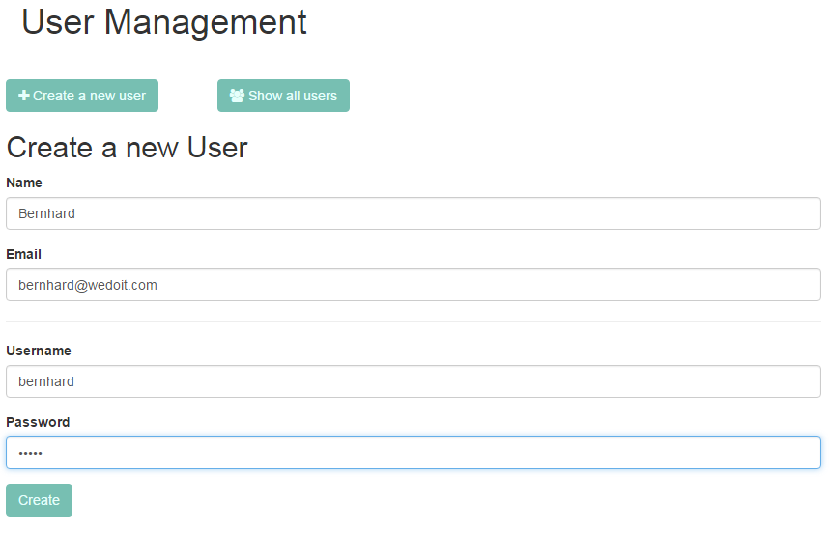

As admin you can create new users. After creating it, it will be possible to log in with this information. To create a new user follow these steps:

1. Navigate to the User Management-Page by click on “User Management” in the left navigation bar
2. Choose “Create a new user”
3. Type in the name and the email for the new user
4. Fill in the Username and the Password for the new user. These two fields are required to login as this user
5. If everything is OK you will see a create button bellow the password-field. Press this in order to create the new user

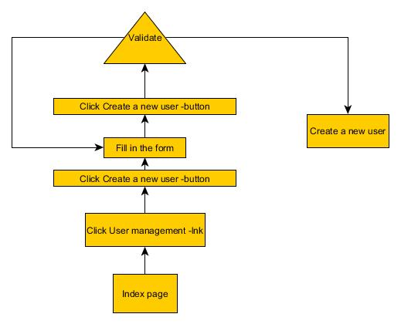

**Show all Users:**

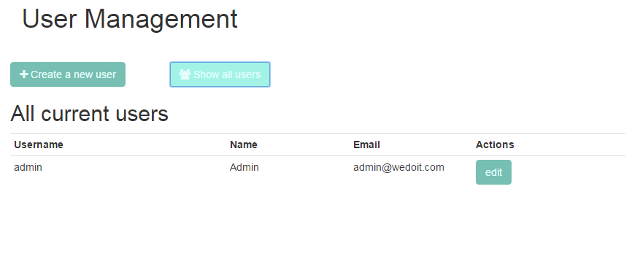

To see all created users which are able to log in follow these steps:

1. Navigate to the User Management-Page by click on “User Management” in the left navigation bar
2. Choose “Show all users”